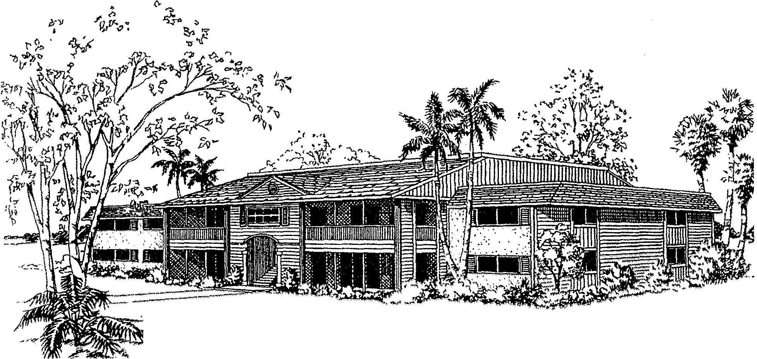
SUMMERLIN WOODS CONDOMINIUM ASSOCIATION, INC.
“A Multi-Association, Limited Access, Gated Community"
Office: Executive Suites at World Plaza
12553 New Brittany Blvd., #32, Fort Myers, Florida 33907
(239) 489-2345• Fax (239) 489-1940
SUMMERLINWOODS@GMAIL.COM
WWW.SUMMERLINWOODSFORTMYERS.COM

LEASE APPLICATION
(REVISION L) (3 MONTH MINIMUM / 9 MONTH MAXIMUM LEASE PERIOD)
(PLEASE TYPE OR PRINT)

UNIT OWNER NAME______________________ _____________________________
UNIT ADDRESS_________________________________________________________

START DATE________________________ENDING DATE_____________________

LEE COUNTY TAX ID NUMBER _________________________________________
FLORIDA STATE TAX ID NUMBER______________________________________

(A) LESSEE NAME (PRIMARY NAME ON LEASE) ___________________________________________________
(A) LESSEE (DOB ___________ (SS#)________________(DL#)_____________(ST)__
CURRENT ADDRESS______________________CITY_________STATE____ZIP___
PRIOR ADDRESS_________________________ CITY_________STATE____ZIP___
EMAIL ADDRESS _______________________________________________________
CONTACT # WORK (___)__________ HOME(___)________ CELL(___)__________
OCCUPATION & POSITION_____________________________________#YRS._____
EMPLOYED BY _________________________________________________________

(B) LESSEE NAME (ADDITIONAL NAME ON LEASE)________________________________________________
(B) LESSEE DOB)____________(SS#)________________(DL#)____________(ST)___
CURRENT ADDRESS_____________________CITY_________STATE_____ZIP____
PRIOR ADDRESS________________________ CITY_________STATE_____ZIP___
EMAIL ADDRESS _______________________________________________________
CONTACT # WORK (___)_________HOME (___)_________CELL(___)___________
OCCUPATION & POSITION____________________________________#YRS.______
EMPLOYED BY_________________________________________________________
PAGE 1 OF 3

ADDITIONAL RESIDENT / OCCUPANT INFORMATION
(LIMIT 2 ADULTS PER BEDROOM) (LIST ALL ADDITIONAL PERSONS THAT WILL OCCUPY THIS UNIT)
(NAME & RELATIONSHIP) (IDENTIFY IF RESIDENT IS UNDER 18YRS OF AGE)

1.) _____________________________________________________________________
2.) _____________________________________________________________________
3.) _____________________________________________________________________
4.) _____________________________________________________________________

VEHICLE INFORMATION (LIMIT 2 PER UNIT BY PERMIT ONLY)
(OPEN- BED TRUCKS, MOTORCYCLES, WATERCRAFT & TRAILERS ARE PROHIBITED ON PROPERTY FOR RESIDENTS & GUESTS)(SEE DOCUMENTS, RULES & REGULATIONS)

(YR)____(MAKE/MODEL)_____________________________________(2/4DR)_____
(CAR/TRUCK/SUV)___________(COLOR)______(LIC/TAG#)_____________(ST)__

(YR)____(MAKE/MODEL)_____________________________________(2/4DR)_____(CAR/TRUCK/SUV)___________(COLOR)______(LIC/TAG#)_____________(ST)__

PET INFORMATION:
( NO PETS ALLOWED FOR TENANTS / NO VISITING PETS ALLOWED FOR GUESTS)

PERSONAL REFERENCE & EMERGENCY CONTACT
NAME _______________________RELATIONSHIP_________________
ADDRESS_________________________CITY___________ST___ZIP___
DAY PHONE (___)______________NIGHT PHONE (___) ____________

LEASING AGENT INFORMATION:
LEASED BY OWNER___REALTOR ____OTHER_____
AGENT NAME & PHONE_______________________________________
AGENT COMPANY NAME & ADDRESS__________________________

PAGE 2 OF 3

APPLICANT AGREEMENT & CONSENT

APPLICANTS DO HEREBY AGREE AND CONSENT THAT THE ASSOCIATION MAY REQUEST
AND OBTAIN ADDITIONAL INFORMATION THAT THE ASSOCIATION DEEMS NECESSARY IN THE PROCESSING OF THIS APPLICATION INCLUDING BUT NOT LIMITING TO THE ENGAGEMENT OF THE SERVICES OF AN INDEPENDENT INVESTIGATIVE SERVICE FOR A CONFIDENTIAL CRIMINAL BACKGROUND REPORT.

$100.00 PER APPLICATION PROCESSING FEE (NON-REFUNDABLE)
( limit two names per application)

$65.00 BACKGROUND INVESTIGATION FEE (PER ADULT RESIDENT OCCUPANT OVER THE AGE OF 18YRS) (NON-REFUNDABLE)

THE PROPER FEE MUST BE SUBMITTED WITH THIS APPLICATION PRIOR TO PROCESSING. MAKE CHECK PAYABLE TO: SUMMERLIN WOODS CONDOMINIUM ASSOCIATION INC.

ACKNOWLEDGMENT
APPLICANTS HEREBY ACKNOWLEDGE RECEIPT OF THE ASSOCIATION DOCUMENTS AND ALL AMENDMENTS THERETO, A COPY OF THE RULES AND REGULATIONS AND AGREE THEY AND THEIR GUESTS WILL FULLY COMPLY WITH SAME. APPLICANTS HEREBY ACKNOWLEDGE THAT NO PETS, MOTORCYCLES, BOATS, TRAILERS ETC. WILL BE BROUGHT UPON THE ASSOCIATION PROPERTY BY THEIR GUESTS OR INVITEES.
APPLICANTS HEREBY CERTIFY AND SWEAR THAT THE INFORMATION PROVIDED IN THIS APPLICATION IS TRUE AND ACCURATE TO DATE TO THE BEST OF THEIR KNOWLEDGE.

NOTE: THIS APPLICATION MUST INCLUDE:
REQUIRED SIGNATURES,
SIGNED COPY OF LEASE,
PROPER FEE FOR APPLICATION AND BACKGROUND CHECK

COPY OF DRIVER LICENSE FOR ALL ADULT RESIDENT OCCUPANTS)

_______________________________________DATE________
SIGNATURE (OWNER/AGENT)

______________________________________________DATE__________
SIGNATURE APPLICANT (A) (PRIMARY NAME ON LEASE)

______________________________________________DATE__________
SIGNATURE APPLICANT (B) (SECONDARY NAME ON LEASE)

PAGE 3 OF 3

