SUMMERLIN WOODS CONDOMINIUM ASSOCIATION, INC.
“A Multi-Association, Limited Access, Gated Community"
Office: Executive Suites at World Plaza
12553 New Brittany Blvd., #32, Fort Myers, Florida 33907
(239) 489-2345• Fax (239) 489-1940
SUMMERLINWOODS@GMAIL.COM
WWW.SUMMERLINWOODSFORTMYERS.COM

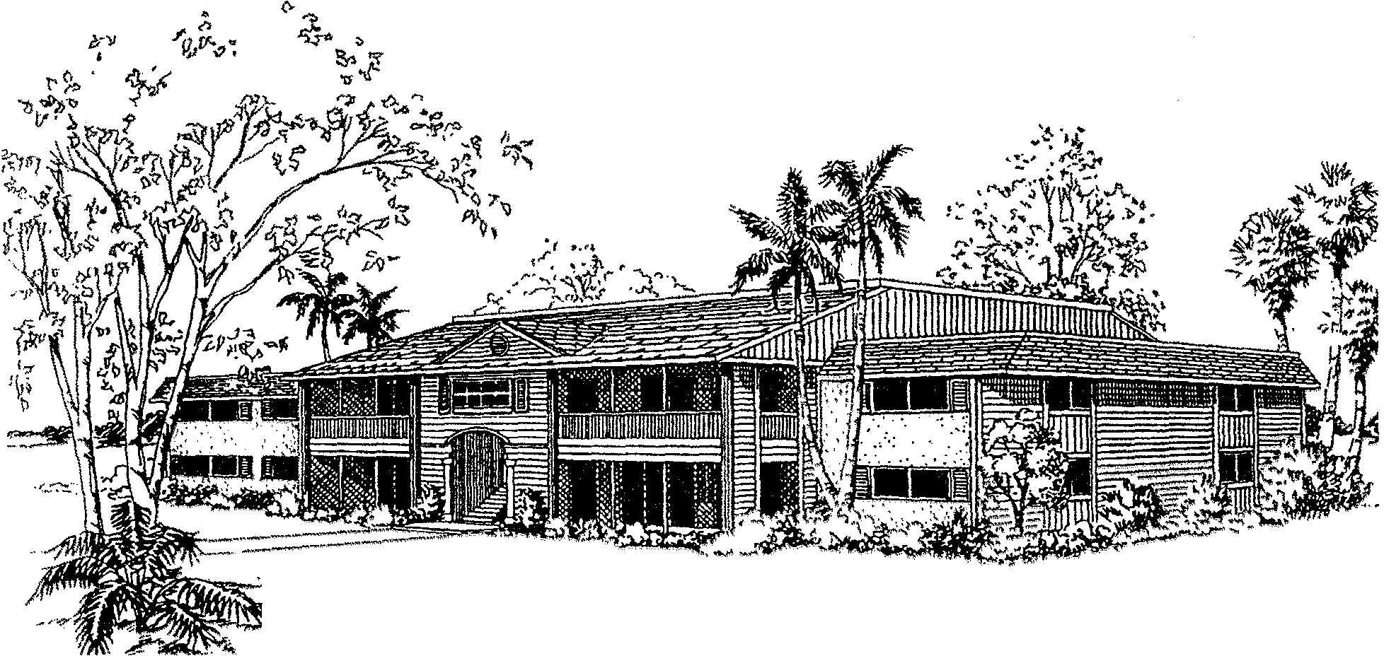
(REVISION M )
SALE APPLICATION
(PLEASE TYPE OR PRINT)

SELLER NAME_______________________UNIT ADDRESS___________________
SALE PRICE $________________________FURN./UNFURN.__________________
FULL TIME RESIDENCE____SECOND HOME___RENTAL INVESTMENT____

(A) BUYER NAME (PRIMARY NAME ON DEED) _____________________________________________________
(DOB)__ ___________ (SS#) ___________________ (DL#) ________________ (ST)__
CURRENT ADDRESS______________________CITY_________STATE____ZIP___
PRIOR ADDRESS_________________________ CITY_________STATE____ZIP___
EMAIL ADDRESS _______________________________________________________
CONTACT / WORK (___) __________ HOME (___) ________ CELL(___)__________
OCCUPATION & POSITION_____________________________________#YRS._____
EMPLOYED BY _________________________________________________________

(B) BUYER NAME (SECONDARY NAME ON DEED) __________________________________________________
(DOB)______________ (SS#) __________________ (DL#)________________(ST)___
CURRENT ADDRESS_____________________CITY_________STATE_____ZIP____
PRIOR ADDRESS________________________ CITY_________STATE_____ZIP___
EMAIL ADDRESS _______________________________________________________
PHONE: WORK (___) __________HOME (___) __________CELL(___)____________
OCCUPATION & POSITION____________________________________#YRS.______
EMPLOYER NAME______________________________________________________

NOTE: ADDITIONAL NAMES ON DEED WILL REQUIRE ADDITIONAL APPLICATIONS. DEEDS TO BE HELD IN A TRUST, CORPORATION, LLC, ETC. MUST SUBMIT ADDITIONAL DOCUMENTATION.

PAGE 1 OF 3

ADDITIONAL RESIDENT / OCCUPANT INFORMATION
(LIMIT 2 ADULTS PER BEDROOM) (LIST ALL PERSONS THAT WILL OCCUPY THE UNIT)
(NAME & RELATIONSHIP) (IDENTIFY IF RESIDENT IS UNDER 18YEARS OF AGE)

1.) _____________________________________________________________________
2.) _____________________________________________________________________
3.) _____________________________________________________________________
4.) _____________________________________________________________________

VEHICLE INFORMATION (LIMIT 2 PER UNIT BY PERMIT ONLY)
(OPEN- BED TRUCKS, MOTORCYCLES, WATERCRAFT & TRAILERS ARE PROHIBITED ON PROPERTY FOR RESIDENTS & GUESTS)(SEE DOCUMENTS, RULES & REGULATIONS)
(YR)___ (MAKE/MODEL) ____________________________________ (2/4DR)____
(CAR/TRUCK/SUV)_________ (COLOR)______(LIC/TAG#)_____________(ST)__

(YR)____(MAKE/MODEL)_____________________________________(2/4DR)_____(CAR/TRUCK/SUV)___________(COLOR)______(LIC/TAG#)_____________(ST)__

PET INFORMATION (IF NONE MARK N/A) (PET ALLOWED FOR OWNERS ONLY / NO VISITING PETS ALLOWED / 20LB. MAXIMUM ADULT WEIGHT / PET PHOTO & VETRENARIAN REGISTRATION REQUIRED), (SEE RULES AND REGULATIONS SECTION 10 REGARDING PET RESTRICTIONS).
DOG/BREED____________CURRENT/ADULT WEIGHT____/____LBS.
CAT/ BREED____________CURRENT/ADULT WEIGHT___/_____LBS.

PERSONAL REFERENCE & EMERGENCY CONTACT
NAME _______________________RELATIONSHIP_________________
ADDRESS_________________________CITY___________ST___ZIP___
DAY PHONE (___) ______________NIGHT PHONE (___) ____________

BUYER AGENT INFORMATION:
COMPANY__________________________BROKER_________________ COMPANY PHONE___________________FAX_____________________
AGENT NAME ______________________CELL____________________
AGENT/COMPANY EMAIL ADDRESS___________________________
____________________________________________________________
LISTING AGENT INFORMATION:
COMPANY__________________________BROKER_________________
COMPANY PHONE___________________FAX_____________________
AGENT NAME______________________ CELL____________________
AGENT/COMPANY EMAIL ADDRESS____________________________

PAGE 2 OF 3
TITLE COMPANY INFORMATION:
COMPANY NAME___________________________________________
COMPANY ADDRESS________________________________________
COMPANY EMAIL ADDRESS_________________________________
PHONE (____) ___________________FAX (____)__________________
DATE OF CLOSING__________________________________________

APPLICANT AGREEMENT & CONSENT
APPLICANTS DO HEREBY AGREE AND CONSENT THAT THE ASSOCIATION MAY REQUEST
AND OBTAIN ADDITIONAL INFORMATION THAT THE ASSOCIATION DEEMS NECESSARY IN THE PROCESSING OF THIS APPLICATION INCLUDING BUT NOT LIMITING TO THE ENGAGEMENT OF THE SERVICES OF AN INDEPENDENT INVESTIGATIVE SERVICE FOR A CONFIDENTIAL CRIMINAL BACKGROUND REPORT.

$100.00 PROCESSING FEE PER APPLICATION (LIMIT TWO NAMES PER APPLICATION)
$65.00 BACKGROUND INVESTIGATION FEE (PER ADULT AND ADDITIONAL OCCUPANTS OVER 18YEARS OF AGE).
(ALL FEES ARE NON-REFUNDABLE) THE PROPER FEE AND FORM MUST BE SUBMITTED PRIOR TO PROCESSING. PLEASE MAKE CHECK PAYABLE TO SUMMERLIN WOODS CONDOMINIUM ASSOCIATION INC. NOTE: LENDER QUESTIONNAIRE FORMS OR ADDITIONAL DOCUMENTATION REQUIRE ADDITIONAL FEES.

ACKNOWLEDGMENT
APPLICANTS HEREBY ACKNOWLEDGE RECEIPT OF THE ASSOCIATION DOCUMENTS AND ALL AMENDMENTS THERETO, A COPY OF THE RULES AND REGULATIONS AND AGREE THEY AND THEIR OCCUPANTS /GUESTS OR TENANTS WILL FULLY COMPLY WITH SAME. APPLICANTS HEREBY ACKNOWLEDGE THAT NO PETS, MOTORCYCLES, BOATS, TRAILERS ETC. WILL BE BROUGHT UPON THE ASSOCIATION PROPERTY BY THEIR OCCUPANTS / GUESTS / TENANTS OR INVITEES.
APPLICANTS HEREBY CERTIFY AND SWEAR THAT THE INFORMATION PROVIDED IN THIS APPLICATION IS TRUE AND ACCURATE TO DATE TO THE BEST OF THEIR KNOWLEDGE.

NOTE: THIS APPLICATION MUST INCLUDE:
- REQUIRED SIGNATURES,
- SIGNED CONTRACT FOR PURCHASE,
- PROPER FEE FOR (APPLICATION AND BACKGROUND)
- COPY OF DRIVER LICENSE (ALL OWNERS & OCCUPANTS)
- PET DOCUMENTATION PER RULES (IF ANY)
- TRUST, LLC, CORPORATION DOCUMENTATION (IF ANY)
_______________________________________DATE________
SIGNATURE (SELLER/AGENT)
______________________________________________DATE__________
SIGNATURE APPLICANT (A) (FIRST (PRIMARY) NAME ON DEED)
______________________________________________DATE__________
SIGNATURE APPLICANT (B) (SECONDARY NAME ON DEED)

PAGE 3 OF 3

